Clean Water Initiative Program
Final Photo Report
[Project Name]
[Subgrant Agreement #]

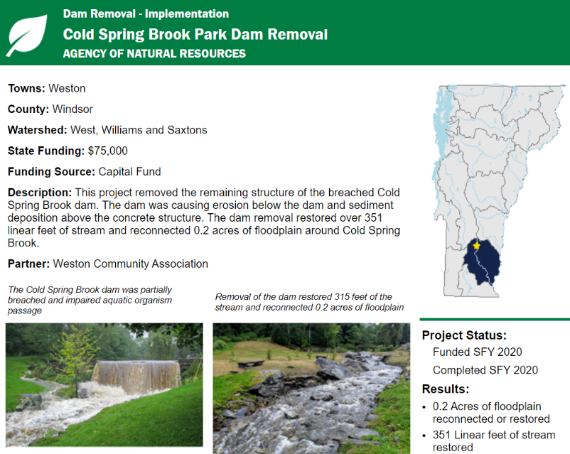
Photo reporting is an essential component of the grant final reporting process. CWIP collects before and after photos of implementation projects in order to illustrate the results of clean water projects to the public in the Vermont Clean Water Initiative Annual Performance Report and Clean Water Project Explorer (see example at right).

Although photos may have been submitted as interim deliverables to the technical project manager, photos and captions must be documented in this form as your final photo deliverable.

If this is a stormwater implementation project that installs multiple BMPs, separate photos must be reported for each BMP included in the Final BMP Report. For these, include Project Name/BMP Type as requested in the template. Below are additional photo templates for this purpose.

Only one template with Before and After implementation photos must be submitted for the following project types:
- Dam Removal – Implementation
- Floodplain/Stream Restoration – Implementation
- Forestry – Implementation
- In-Lake Treatment – Implementation
- Lake Shoreland – Implementation
- River – Planting
- Road Project – Implementation
- Stormwater – Implementation (one photo template for each BMP reported)
- Wetland Restoration - Implementation

At least one photo must be submitted for the following project types.
- River Corridor Easement – Implementation
- Forestry – Equipment
- Stormwater/Roads Equipment

Photos must be a minimum resolution of 300 pixels per inch, and file size must be less than 8 MB. Implementation photos should be taken from the same perspective before and after project implementation, and equipment photos must be taken of the equipment in use.

Watershed Projects Database ID
Project Name / BMP Type

Before Implementation (or Photo #1 for equipment or River Corridor Easements) | After Implementation (or Photo #2 for equipment or River Corridor Easements)
Photo Caption. Must be one complete sentence describing the location and content of the photo: | Photo Caption. Must be one complete sentence describing the location and content of the photo:
Photo Date: | Photo Date:

Watershed Projects Database ID
Project Name / BMP Type

Before Implementation (or Photo #1 for equipment or River Corridor Easements) | After Implementation (or Photo #2 for equipment or River Corridor Easements)
Photo Caption. Must be one complete sentence describing the location and content of the photo: | Photo Caption. Must be one complete sentence describing the location and content of the photo:
Photo Date: | Photo Date:

Watershed Projects Database ID
Project Name / BMP Type

Before Implementation (or Photo #1 for equipment or River Corridor Easements) | After Implementation (or Photo #2 for equipment or River Corridor Easements)
Photo Caption. Must be one complete sentence describing the location and content of the photo: | Photo Caption. Must be one complete sentence describing the location and content of the photo:
Photo Date: | Photo Date:

.

Watershed Projects Database ID
Project Name / BMP Type

Before Implementation (or Photo #1 for equipment or River Corridor Easements) | After Implementation (or Photo #2 for equipment or River Corridor Easements)
Photo Caption. Must be one complete sentence describing the location and content of the photo: | Photo Caption. Must be one complete sentence describing the location and content of the photo:
Photo Date: | Photo Date:

